What is Version Control?
GIT stands for:
G – Global
I – Information
T – Tracker

GIT = Global Information Tracker

Version Control is a system that helps you track, manage, and control changes made to files (usually source code) over time.
In simple words:
It keeps a history of your work so you can see who changed what, when, and why, and you can go back to earlier versions if needed.

About Version Control
What is “version control”, and why should you care?
Version control is a system that records changes to a file or set of files over time so that you can recall specific versions later.

Local Version Control Systems
Many people’s version-control method of choice is to copy files into another directory (perhaps a time-stamped directory, if they’re clever).
This approach is very common because it is so simple, but it is also incredibly error prone.
It is easy to forget which directory you’re in and accidentally write to the wrong file or copy over files you don’t mean to.
To deal with this issue, programmers long ago developed local VCSs that had a simple database that kept all the changes to files under revision control.

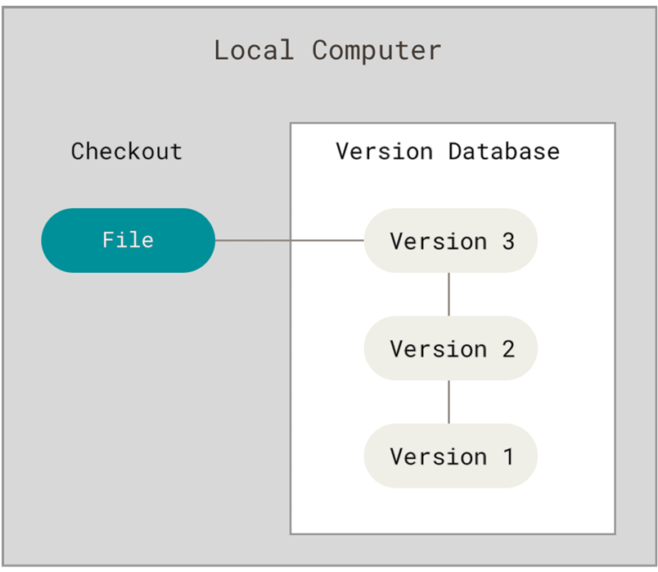

One of the most popular VCS tools was a system called RCS, which is still distributed with many computers today.
RCS works by keeping patch sets (that is, the differences between files) in a special format on disk; it can then re-create what any file looked like at any point in time by adding up all the patches.

Centralized Version Control Systems
The next major issue that people encounter is that they need to collaborate with developers on other systems.
To deal with this problem, Centralized Version Control Systems (CVCSs) were developed.
These systems (such as CVS, Subversion, and Perforce) have a single server that contains all the versioned files, and a number of clients that check out files from that central place.
For many years, this has been the standard for version control.

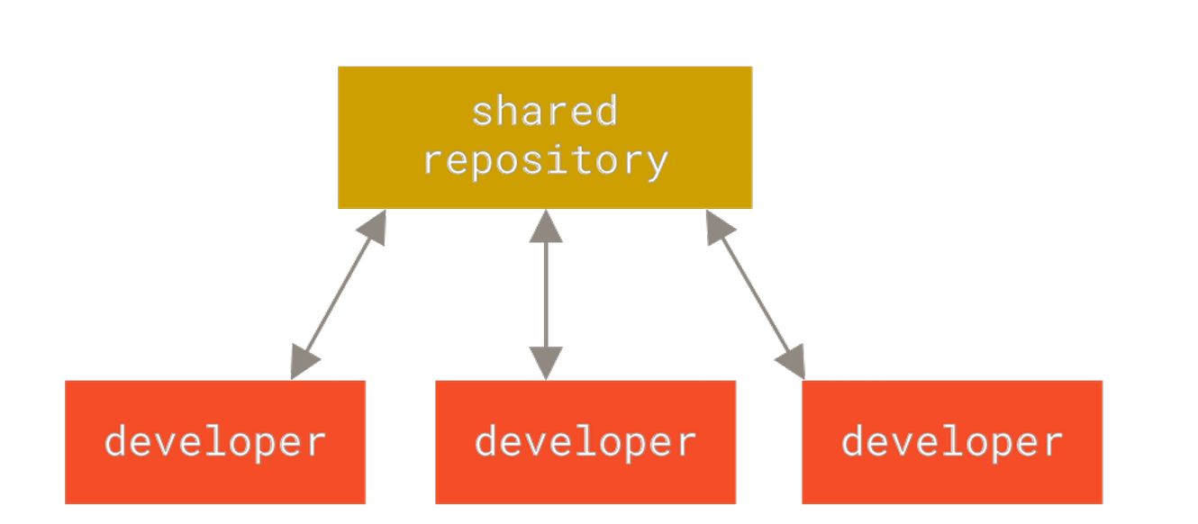

Distributed Version Control Systems
This is where Distributed Version Control Systems (DVCSs) step in.
In a DVCS (such as Git, Mercurial or Darcs), clients don’t just check out the latest snapshot of the files; rather, they fully mirror the repository, including its full history.
Thus, if any server dies, and these systems were collaborating via that server, any of the client repositories can be copied back up to the server to restore it.
Every clone is really a full backup of all the data.

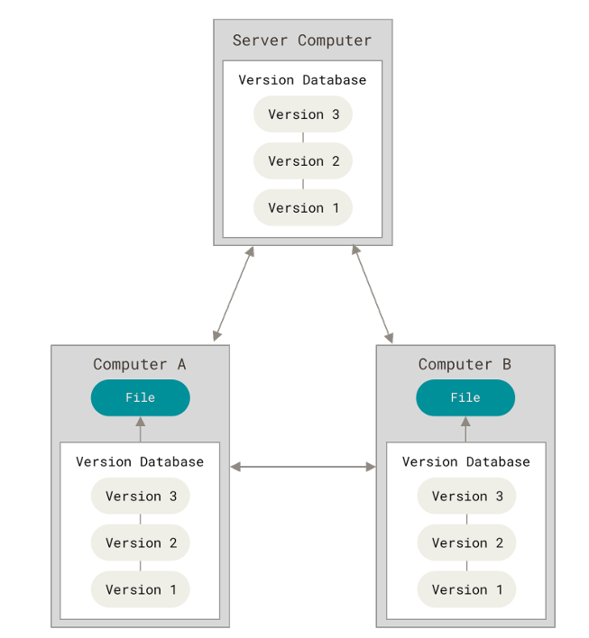

A Short History of Git
As with many great things in life, Git began with a bit of creative destruction and fiery controversy.
The Linux kernel is an open source software project of fairly large scope.
During the early years of the Linux kernel maintenance (1991–2002), changes to the software were passed around as patches and archived files.
In 2002, the Linux kernel project began using a proprietary DVCS called BitKeeper.
In 2005, the relationship between the community that developed the Linux kernel and the commercial company that developed BitKeeper broke down, and the tool’s free-of-charge status was revoked.
This prompted the Linux development community (and in particular Linus Torvalds, the creator of Linux) to develop their own tool based on some of the lessons they learned while using BitKeeper.
Some of the goals of the new system were as follows:
• Speed
• Simple design
• Strong support for non-linear development (thousands of parallel branches)
• Fully distributed
• Able to handle large projects like the Linux kernel efficiently (speed and data size)

Since its birth in 2005, Git has evolved and matured to be easy to use and yet retain these initial qualities.
It’s amazingly fast, it’s very efficient with large projects, and it has an incredible branching system for non-linear development.

Why Version Control is Important
1. Track Changes
- Records every modification to files
- Lets you compare old and new versions
2. Collaboration
- Multiple developers can work on the same project
- Avoids overwriting each other’s work
3. Backup & Recovery
- If something breaks, you can revert to a stable version
- Prevents data loss
4. Experiment Safely
- Create branches to try new features
- Merge changes only when they work correctly

Types of Version Control Systems
1. Local Version Control
- Stores versions on your local machine
- Example: manual backups (not common today)
2. Centralized Version Control (CVCS)
- One central server
Examples:
  - SVN(Subversion)
  - CVS(Concurrent Versions System)
3. Distributed Version Control (DVCS)
- Every developer has a full copy of the repository
- Examples:
  - Git (most popular)
  - Mercurial

Example (Real-Life Analogy)
Think of a Microsoft Docs file:
- You can see revision history
- Restore previous versions
- Multiple people can edit together
➡ That’s version control for documents; Git does the same for code.

Most Popular Tool
Git
Used with platforms like:
- GitHub
- GitLab
- Bitbucket

1. What is Git?
Git is a distributed version control system used to track code changes and collaborate with teams.
Key Benefits
✔ Version history
✔ Team collaboration
✔ Rollback changes
✔ Branch-based development

2. Git Basics & Common Commands
2.1 Install & Configure Git
Download Git for Windows
Open this link in your browser:
https://git-scm.com/download/win
✔ Download starts automatically
✔ File name like: Git-2.xx.x-64-bit.exe

Install Git (IMPORTANT OPTIONS)
Double-click the installer and follow these exact selections:
✔ Step-by-step choices
- Select Components
  - “Git Bash Here”
  - “Git GUI Here”
  - “Add Git to PATH” (very important)
- Adjust PATH Environment
  - Git from the command line and also from 3rd-party software
- Default Editor
  - Choose VS Code (recommended) or Notepad++
- Keep all other options default
- Click Install
Restart Terminal
After installation:
- Close Command Prompt / PowerShell
- Open new terminal
Now test:
git --version
✔ Expected output:
git version 2.xx.x.windows.x

Verify Git in VS Code
Open VS Code terminal:
git --version
If it works here → you’re good

If Still Not Working (PATH Fix)
Manual PATH Check (Windows)
- Press Win + R → type sysdm.cpl
- Go to Advanced → Environment Variables
- Under System variables → Path
- Ensure these exist:
C:\Program Files\Git\cmd
C:\Program Files\Git\bin
- If missing → Add them
- Restart PC (recommended)

LINUX
sudo apt update
sudo apt install git -y

macOS
brew install git
or
xcode-select --install

After Git Works (Next Mandatory Setup)
Run once:
git config --global user.name "Your Name"
git config --global user.email "your@email.com"
Verify:
git config --list

2.2 Creating a Repository

Creating a Git Repository (git init)
To start using Git for a project, you first need to create a Git repository. This is done using the command:
git init

What does git init do?
- Creates a new, empty Git repository
- Adds a hidden .git folder to your project
- Enables Git to start tracking changes in that directory
The .git folder stores:
- Commit history
- Branch information
- Configuration settings

Step-by-Step Example
1. Create or open a project folder
mkdir my-project
cd my-project
2. Initialize Git
git init
it will create a repository called master
If you want to create a named repository, main, give the following command
>git init main

Output:
Initialized empty Git repository called main in C:/my-project/.git/

Check Repository Status
git status
This shows:
- Untracked files
- Staged files
- Current branch (usually main)

Staging:
What is Staging in Git?
Staging is an intermediate step between modifying files and committing them to the repository.
It lets you choose exactly what changes you want to include in the next commit.

Git’s Three Main Areas
Working Directory → Staging Area → Repository
(edit files) (git add) (git commit)

Area | Meaning
Working Directory | Where you edit files
Staging Area (Index) | Where you prepare selected changes
Repository | Where commits are stored

Why Staging Is Important
Without staging, every change would be committed together.
Staging allows you to:
✔ Commit only relevant changes
✔ Create clean, meaningful commits
✔ Separate features, bug fixes, and formatting
✔ Review changes before committing

Example: Staging in Action
Modify Files (let assume these two files are already there(Login.java, Setting.java))
Login.java
public class Login {
public static void main(String args[]) {
System.out.println("Please login.");
}
}
Setting.java
public class Setting {
public static void main(String args[]) {
System.out.println("Set me");
}
}

You edit two files:
Login.java
System.out.println(“You have logged in.”);

Setting.java
System.out.println(“You did the settings.”);
Check Status
git status
Output:
modified: login.py
modified: settings.py
Stage Only One File
git add login.py
Now:
git status
staged: login.py
not staged: settings.py
Commit Staged Changes
git commit -m "Fix login validation"
Only Login.java is committed.

To display whatever we did use the following command
>git log

Key Staging Commands
Command | Purpose
git add file.txt | Stage a specific file
git add . | Stage all changes
git reset file.txt | Unstage a file
git status | View staging state

Undoing Changes
git checkout -- file.txt # Discard changes
git reset HEAD file.txt # Unstage file
git revert commit_id # Undo a commit safely

